Screenshot of Output
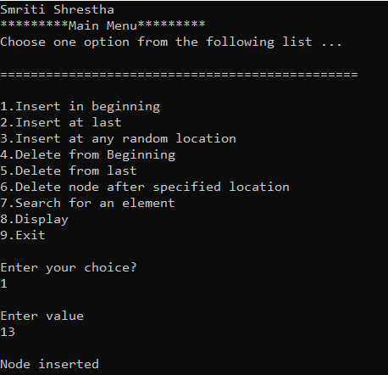
Singly Linked List

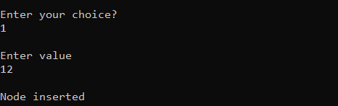
0

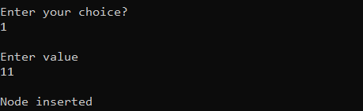

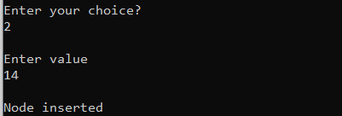

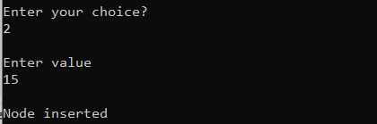

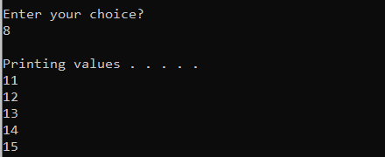
0

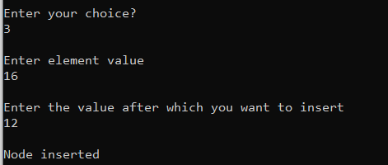

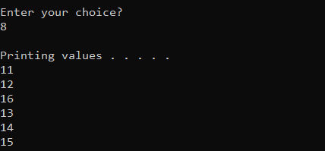

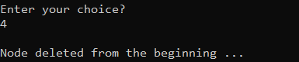
0

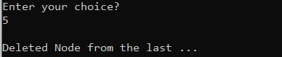

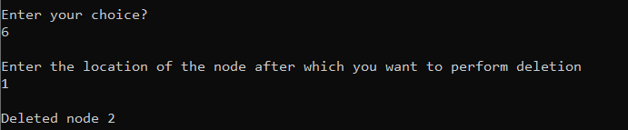

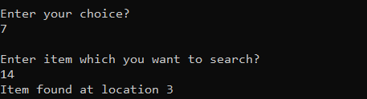

Doubly Linked List
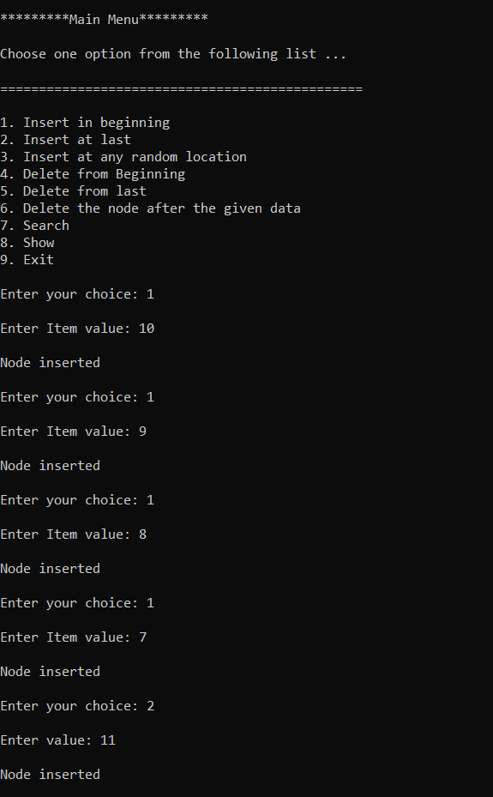

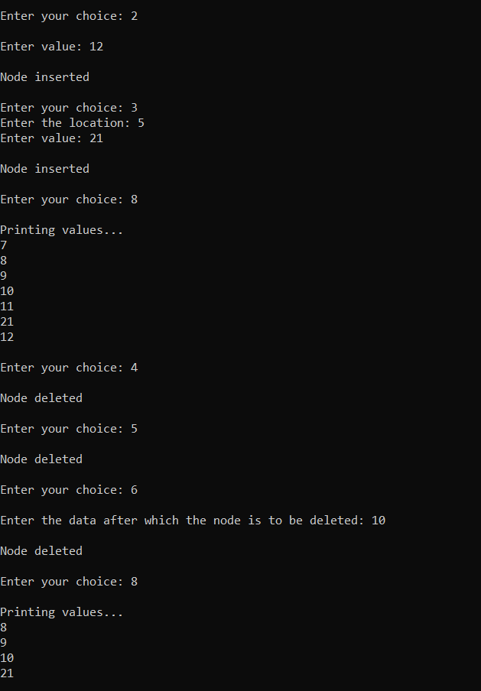
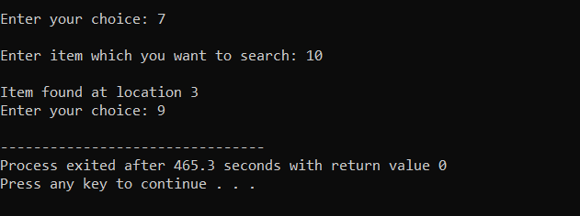

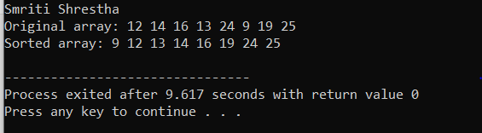
Merge Sort

Quick Sort
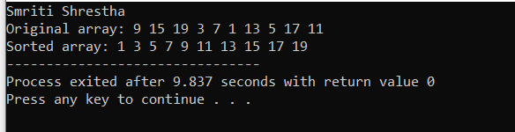
Insertion Sort
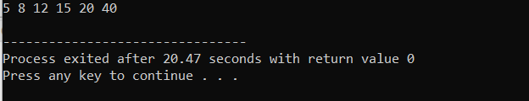
Selection Sort
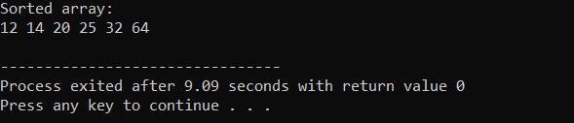
Fibonacci Series
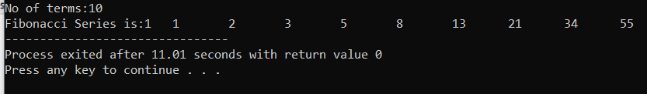
Binary Search Tree (BST)
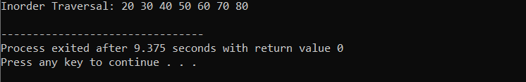

Linear Search
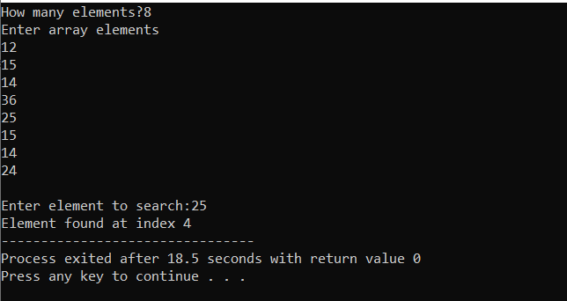
Binary Search
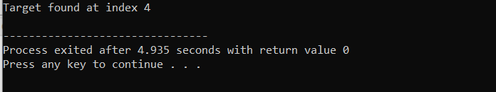

Tower of Hanoi
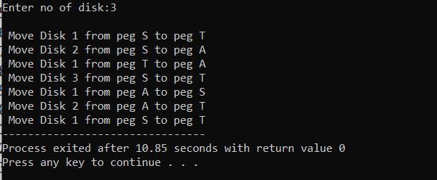

TABLE OF CONTENTS
LAB 1 | Implementation of Stack
LAB 2 | Implementation of Queue
LAB 3 | Implementation of Circular Queue
LAB 4 | Implementation of Singly Linked List
LAB 5 | Implementation of Doubly Linked List
LAB 6 | Implementation of Fibonacci series
LAB 7 | Implementation of Quick and Merge Sort, Insertion and Selection
LAB 8 | Implementation of Linear Search
LAB 9 | Implementation of Binary Search
LAB 10 | Implementation of Linear Hashing
LAB 11 | Implementation of BST
LAB 12 | Implementation of TOH

